
Bryan Gan Zijun | 234024M | May 30, 2025

FYPJ Research Project Documentation
  - AI CHatbot and Classification

Project Overview

Aim
To build an AI chatbot and data classification system tailored to the NYP Data Classification Systems with the goal of helping staff efficiently answer CNC-related questions and accurately apply security classifications, reducing reliance on manual searches through documentation.

Rationale
The previous 2 batches of the projects laid down an extremely decent workflow for the chat bot. However, it was extremely simple only having a chatbot and a file upload whereas the second one had the addition of signing in as well as a data classification. Neither have persistent memory to store the conversations which were practically gone when the program was stopped. Therefore, if I were to improve the overall code base, I would have to introduce a collection of small features to improve the code’s overall quality of life.

Past Implementation Review

First Batch WORKflow
The first batch used different libraries they handpicked such as pdfminer, docx, pptx, openpyxl to extract data from a provided dataset which they dump into a single text file called extracted_text.txt. After using this text file, they chunk it using the recursive chunking function provided by langchain, before batching, embedding and creating a chroma database from the text.
For data processing, the file is upload from the front end using streamlit’s file uploader and passed into the back end where there is a function to validate the file type using the file name after which it would load the text onto extracted_text.txt, after which extracted_text.txt is loaded in chunked and the chroma db is created again using the full text.
The user query is passed from the streamlit’s text input to the backend where it is that is not a letter, number, space, full stop, comma, question, exclamation mark or dash is cleaned using regex for the chatbot. Then the query is passed to the RAG LLM model, where it goes through multi query transformation where it’s generated into multiple versions/phrasing to accommodate multiple questions that may exist in the query. After which it is passed into history aware prompt, which determines if the query requires the chat history to provide reference to a previous context in the chat session. If the chat history is needed, a new standalone question is generated that can be understood without the chat history.
The final query is then embedded and passed into the vector database. A similarity search is then done on the query and retrieves the top 3 vectors that have the highest similarity scores. The relevant context (vectors) and the answering prompt are then into the LLM for the last time to return an answer to the user. And the answer is displayed to the user.

First batch analysis
While they built functions to deal with varied types of files such as powerpoint, excel, word documents and pdf, these formats chose because they were the format the CNC database was in. There was much more potential to incorporate other forms of unstructured files such as more commonly image processing to accommodate someone who for example screenshot a text they say online that they wanted to ask about instead of shoving it into a file just to upload.
The extract_text.txt is not exactly a good idea, the contents of one file may bleed over to another in a text file and furthermore the source in the metadata would point to the text file and not the original file the contents were extracted from. There was a logic error I noticed because the file uploader doesn’t clear the file when it is uploaded that when you ask a question the file is uploaded repeatedly causing duplicates in extracted_text.txt which in turn causes duplicates in the vector store. This in turn might cause the model to be biased towards the uploaded data.
This prototype is good for only one conversation and once the program ends, the conversation will just disappear, and furthermore past questions could not be displayed. While one could argue that this could just be a discreet question and answer machine, I believe that this is a system that is integral to most staff and that past questions should not be simply discarded or logged in a confusing area that only the developers can access.
Furthermore, they’re missing out a key feature to classify the data if let’s say someone wanted to process a text to figure what was the security category of the file before sending it out which is what the ‘c’ in NYP cnc stood for, chatbot and classification. This was an integral part of nyp data security as well as of the chat bot.

Second Batch Workflow
The second batch’s workflow is largely the same with some notable changes. The first change is within text extraction logic where instead of using the pdfminer they changed the algorithm to tesseract which is google’s ocr to extract files from the pdfs. Other than the pdfs, the rest of the files still largely used the same functions and it all extract to the same text file. A feature was added to deal with each file to prevent any error popping up in the code through the use of try with logging if any did pop up with an error.
The data chunking was changed rather dramatically, with the chunks being established manually using splicing and text manipulation as compared to previously where the students used a function provided by langchain to accomplish chunking. They were first split by paragraph and then split at every 512 characters. Furthermore, they cleaned the text to only contain letters as well as spaces and after which filter the empty chunks as well as duplicates which they removed using sets. For initializing the vector store that initialize it at the start of the file using the chroma db class provided by langchain and add documents to it, they also started to use collections within chroma db.
The integration got changed to fastapi from flask, they also implemented postgres sql to store the past conversations as well a account system although they didn’t implement a way to register. They used svelte for the front end as well as docker to handle all the dependencies and running of the program. To note as compared to the previous batch where it was just a singe page with the file upload as well as the chatbot, this has multiple pages such as the login page, chatbot as the front page, file upload and data classification.
The file upload has the roughly the same logic with some improvements like a dynamic folder system to store any data being uploaded, where the file is organized into folders categorized by the file type. The file contents is then automatically pushed into the vector store instead of being processed and put into the text file. This logic is reused in the data classification. However, after extracting the text they process it differently by taking the first 40 000 and the last 40 000 characters and pass it into the data classification model, which is simply an adaptation of the chat model. The input is rephrased into three rephrasing using the multiquery prompt and passed into the chat history prompt where it is rephrased into a standalone paragraph if certain sentences are cut off by splicing. After which a security category and the reasoning is sent back.

Second Batch Analysis
While using google’s ocr is an innovative move to try to improve the pdf text extraction it fell into common traps ocr falls into in which certain characters are not interpreted correctly. It’s slightly disappointing that they thought of ocr to extract pdf but didn’t think of using it to expand the files the program can process given the addition of the data classification which might require additional file support such as emails.
I disagree with the approach to clean the initial dataset so vigorously, after testing say for example, a instruction set on how to categorize the security category of a file that used numbers like if yes, go question 5, which became unusable when asking about it in the model which without the number just assumed the questions were just leading to the next one like a checklist. Furthermore, the manual splicing would cause certain text to be mangled which could cause issues whereas it solved using a llm in data classification, it just remains an issue in data chunking. But there are good points such as adding to a database instead of constantly recreating it.
They solved the duplication issue simply by putting the file and the chat bot on different pages as well as providing a new and nice ui by paginating each feature.

System Overview

Data Processing
- The text is extracted using the unstructured open source library, which is a library that uses libmagic to detect the file type using the file’s encodings and after which extracts the text using the appropriate functions and then turned into a langchain document object.
- The document object is then passed to langchain’s openai metadata tagger where the document is tagged with 10 new metadata labelled as keyword_n where n is arbitrary number from 0-9.
- These keywords is then saved to persistent storage using shelve and called keywords databank
- The document is then chunked into semantic chunks using the semantic chunker which are chunks that are complete and self-contained without any overlap between each chunk. Remaining logical while reducing redundancies.
- After which it is passed onto for batching for efficiency
- Then it is passed into one of two collections based on what was specified in the dataprocessing function, by default it is chat for the chat model, but the other option is classification which is the documents specifically for classification.

Chat Model
- The question, username and chat_id is passed from the front end to the back end
- The chat model takes in the thread id which is the chat id and pulls the conversation memory from the sqlite3 database.
- The user query/question goes through the multi query transformation, where the single query is regenerated into multiple versions/phrasing to accommodate for multiple questions that may exist in the query.
- The now multiple queries will get passed into the chat history prompt, which determines if the query requires the chat history to provide reference to a previous context in the chat session. If the chat history is needed, a new standalone question is generated that can be understood without the chat history.
- The final query is then embedded and passed into the vector database.
- The user query is entered into a llm prompt where it is used to perform text classification/ data labelling where it retrieves the most relevant keywords from the keywords databank based on the question asked.
- The keywords is then used as a filter on the vector store retrieval and after which it will perform similarity search and pick a top 5 within filtered documents, to side step certain limitation of the keyword retrieval, the retriever results is bundled with a unfiltered retriever that will perform the exact same similarity search and pick the top 5 within the unfiltered documents and the results are combined using an ensemble retriever.
- The relevant context (vectors) and the answering prompt are then into the LLM for the last time to return an answer to the user.
- The responses is saved in a folder categorized by the username and thus the username is used to pull the appropriate folder and json file and then, the chat_id, timestamp, question and answer is saved to the correct json file

File Uploads
- The file uploader object has an option to take in multiple files and will return a list of the files.
- The list is iterated through, and the files are passed from the front end to the back end and a temporary directory is created
- The file is saved to the temporary directory.
- Then it is processed through data processing
- After which the file type is detected using libmagic through the function detectFileType and the appropriate folder which is categorized by file type is located or created if it doesn’t exist
- The file is copied over with a new name that indicates the original filename, the username to track who uploaded the file, the timestamp, random characters to ensure it’s unique and the actual file extension.
- Then the temporary folder is deleted
- Then show the users how many files failed and how many passed

Classification Model
- The same logic as file uploads steps 1 and 2
- The file contents is extracted using a function from data processing and then passed into the classification model
- The classification model takes it in and rephrases it into 3 separate rephrasing to extract out the key topics of the text
- After which the multi query is passed to the vector store and it performs a similarity search and retrieves the top 3 based on the highest similarity score
- It passes back the answer which contains the security category, sensitivity of the content as well as reasoning to the user
- The temporary folder is deleted

Code and Comments

dataProcessing.py

dataProcessing
This is an in depth explanation for data processing as most of it is done with functions langchain and it might not be as obvious what they are doing.
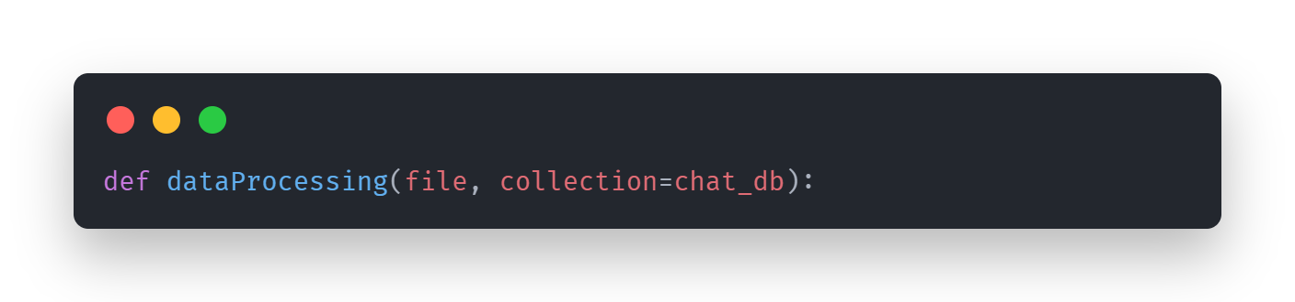
This is the main function, which takes in the file path (as a string) and a ChromaDB object from the langchain-chroma integration package. Collections are the grouping mechanism for embeddings, documents, and metadata within ChromaDB.
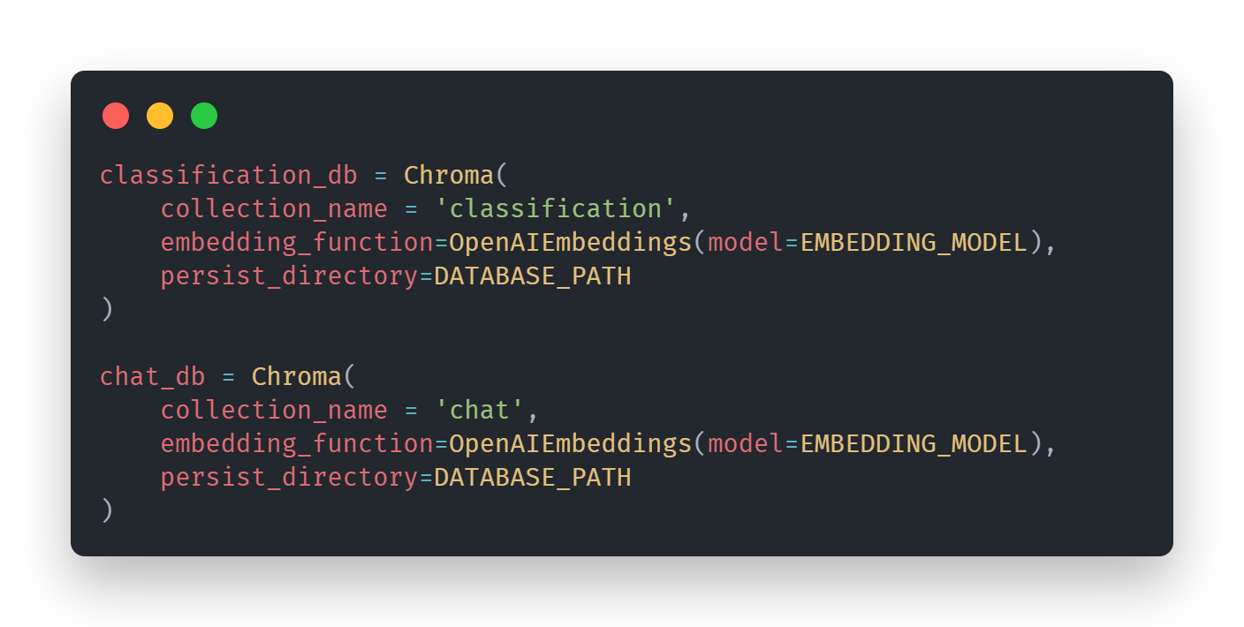
This code base has two collections, one for the chat model and one for the classification model. By default, the function stores documents in the chat_db collection unless another collection is specified. This is due to other than the initialization of the vector store, the other part of the code base that relies or utilizes the dataProcessing heavily is within file uploads functionality in app.py.
The chroma function provided by langchain shown above also conveniently creates the vector store if it is not present.

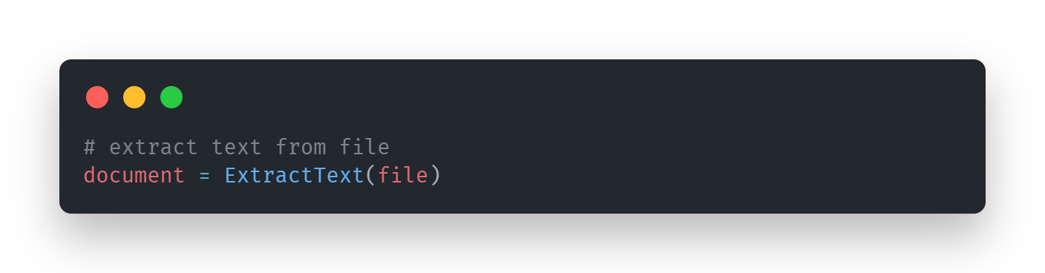
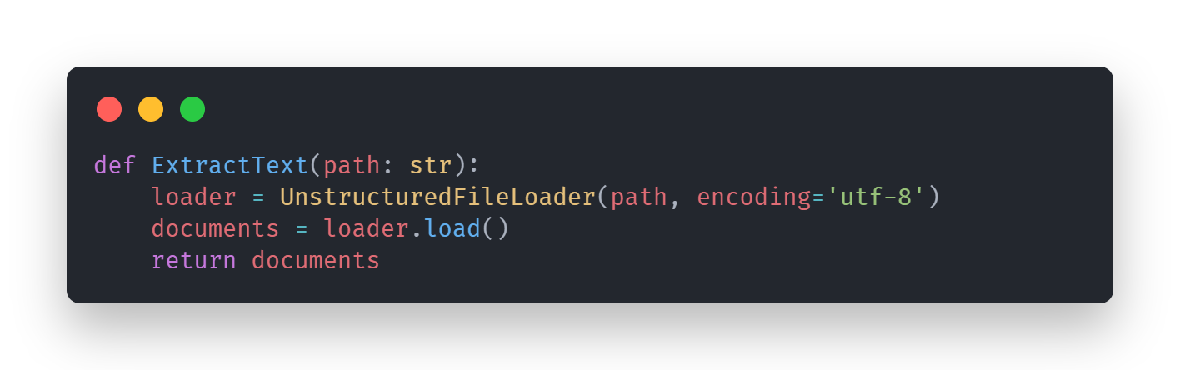
This is the first part of the dataProcessing function, the ExtractText function which does exactly what it says, it takes in a file path (as a string) and extracts the contents of the file on that file path. It uses the UnstructuredFIleLoader which is an extension of unstructured partition with langchain's document loaders. It uses the unstructured library’s partition function which uses libmagic to detect the file type and uses the corresponding functions and logic to extract the text, langchains takes the extracted text and converts it into a langchain Document object.
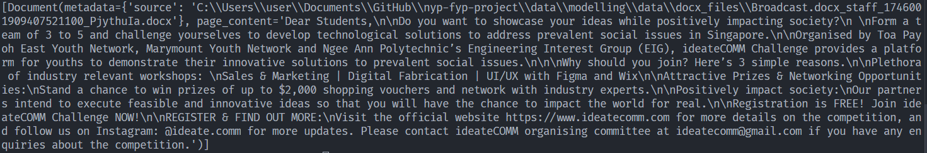
Example of a langchain document object
A langchain Document object consists of two attributes, metadata and page contents. The metadata is a dictionary, which contains source which is the file path, and the page content string that contains the text contents extracted from the file.
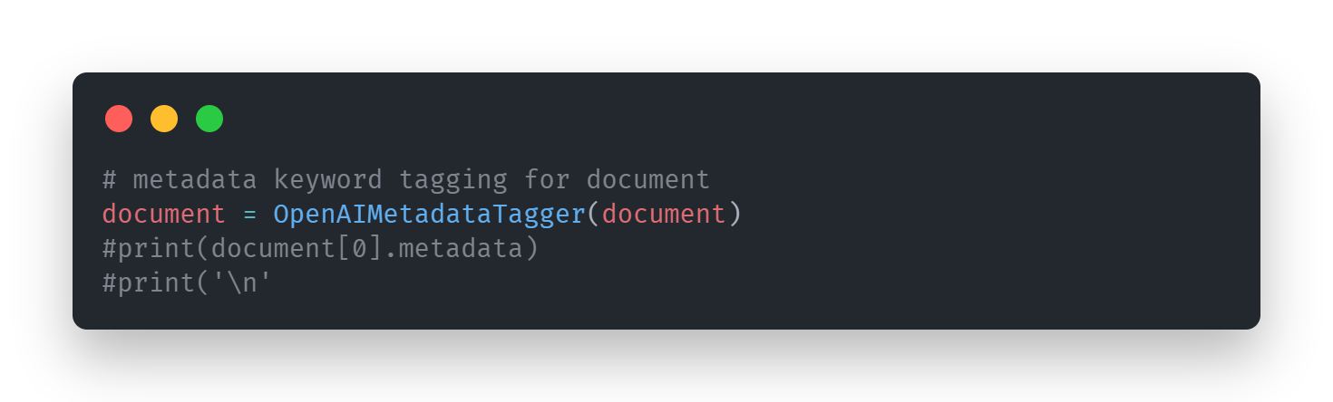
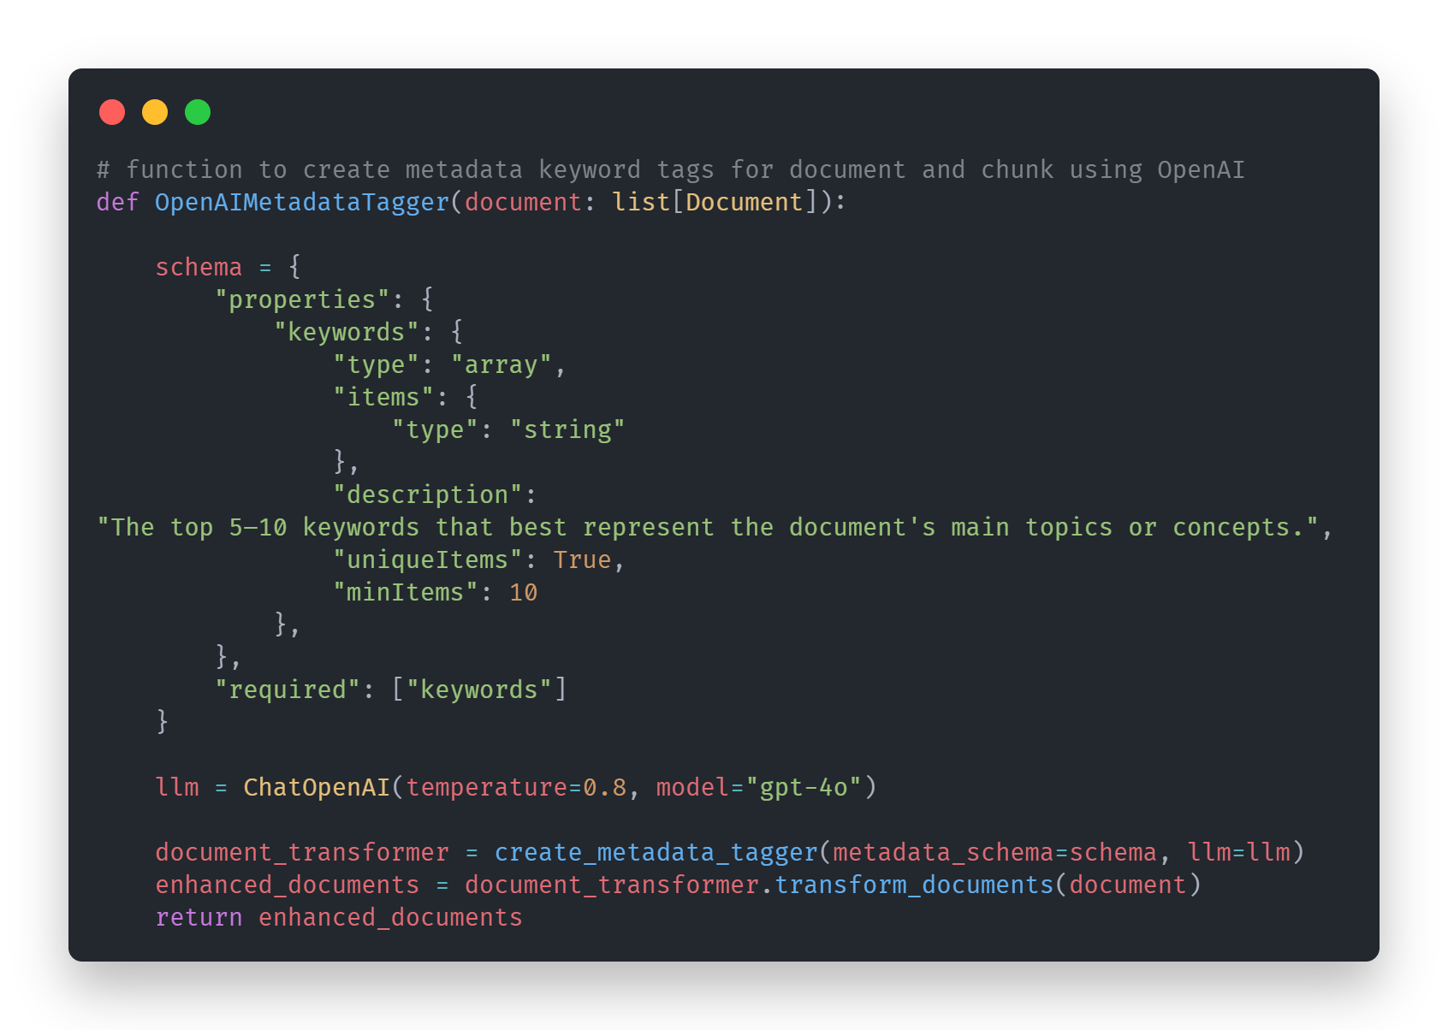
The second part of dataProcessing is the metadata keywords tag which uses langchain’s OpenAI metadata tagger which uses a configurable OpenAI Functions-powered chain under the hood. It tells Open AI to return an array of strings containing exactly 10 unique items that best represent the document’s main topics or concepts, these 10 items are exact words or phrases from the document itself and applies it to the document’s metadata. Thus now the metadata attribute of the langchain Document object consists of two items, the source, a string of the document’s file path and the keywords, a list of 10 unique words or phrases from the document.
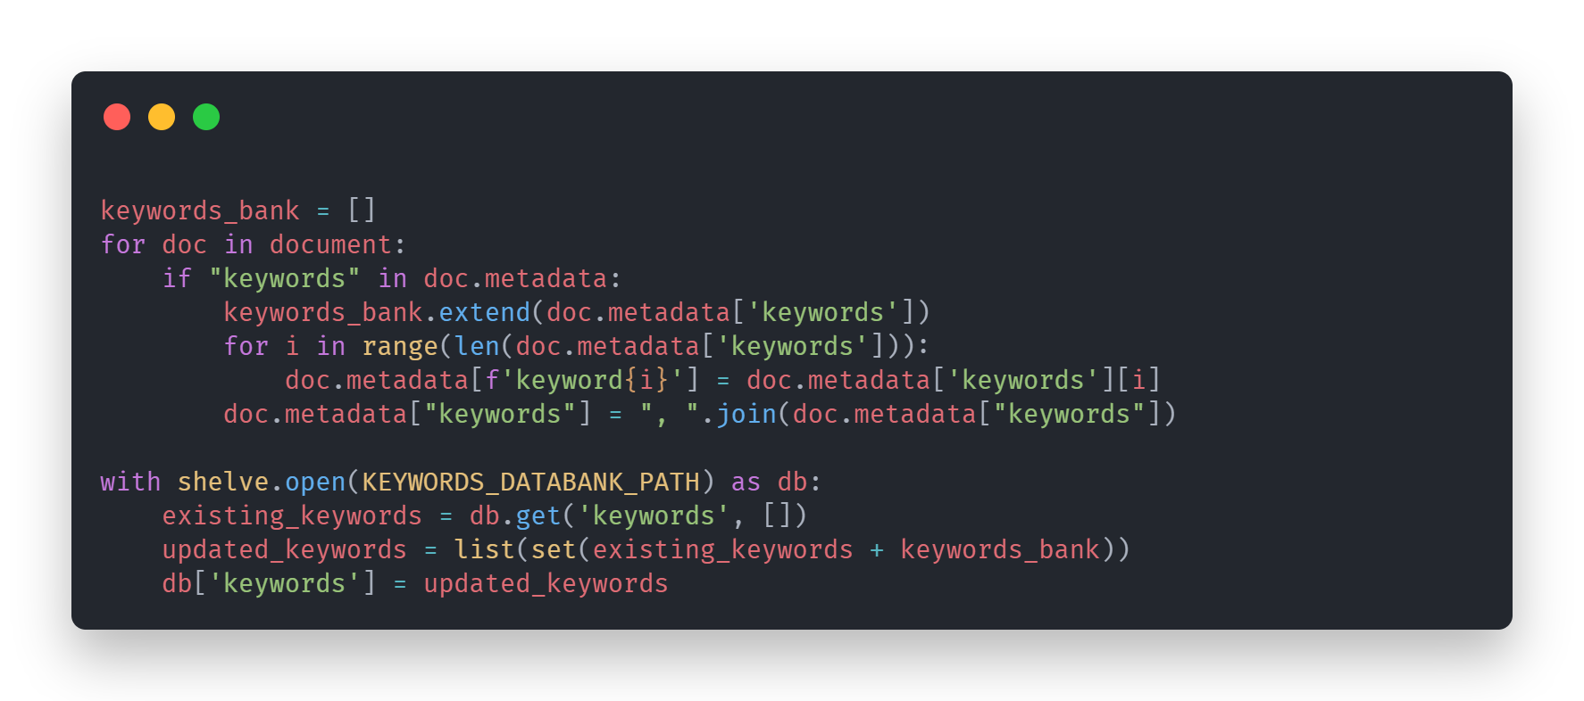
Chroma db’s metadata for each vector has two limitations that this keywords metadata has bumped up against which are:
- Chroma cannot take in a metadata that contains complex data types and can only take in strings, integers and booleans
- Chroma can only do an exact matching for string metadata when doing filtering
The code above shows how I have chosen to deal with these limitations. The first limitation is easier to understand and solve, chroma db just simply does not support this functionality to support complex data types.¹
The solution is simply to convert the list to simpler datatypes such as a string. However, we also have to deal with the second limitation which is that chroma is only capable of exact matching if let’s say we were to use the metadata to filter the documents later on. So, if we just simply joined all the items in the keywords list into a string, chroma would be incapable of using it if you were simply only trying to match one keyword in the string. Thus, that it is why it is separated out into individual keywords metadata. The original keywords metadata is being kept in as a backup and for posterity.
Furthermore, to facilitate the exact matching, a function called match_keywords in chatModel.py was written to utilize open ai chat gpt to do text classification to match the question to the existing keywords which is in a databank, which is all the keywords collected into a list and stored into a persistent storage using shelve as shown above. This will be further explained in the section which details chatModel.py.

¹ There is a link detailing a feature request on github being made for chroma to support arrays, but it was not solved and closed as a duplicate because the feature was already being requested multiple times as an issue on github and the link to where they were tracking the implementation of this feature still shows it as an opened and unsolved. – 29/05/2025
Link to feature request: https://github.com/chroma-core/chroma/issues/227
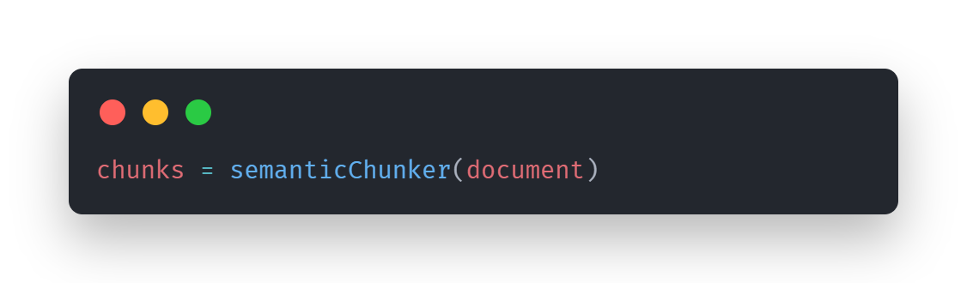
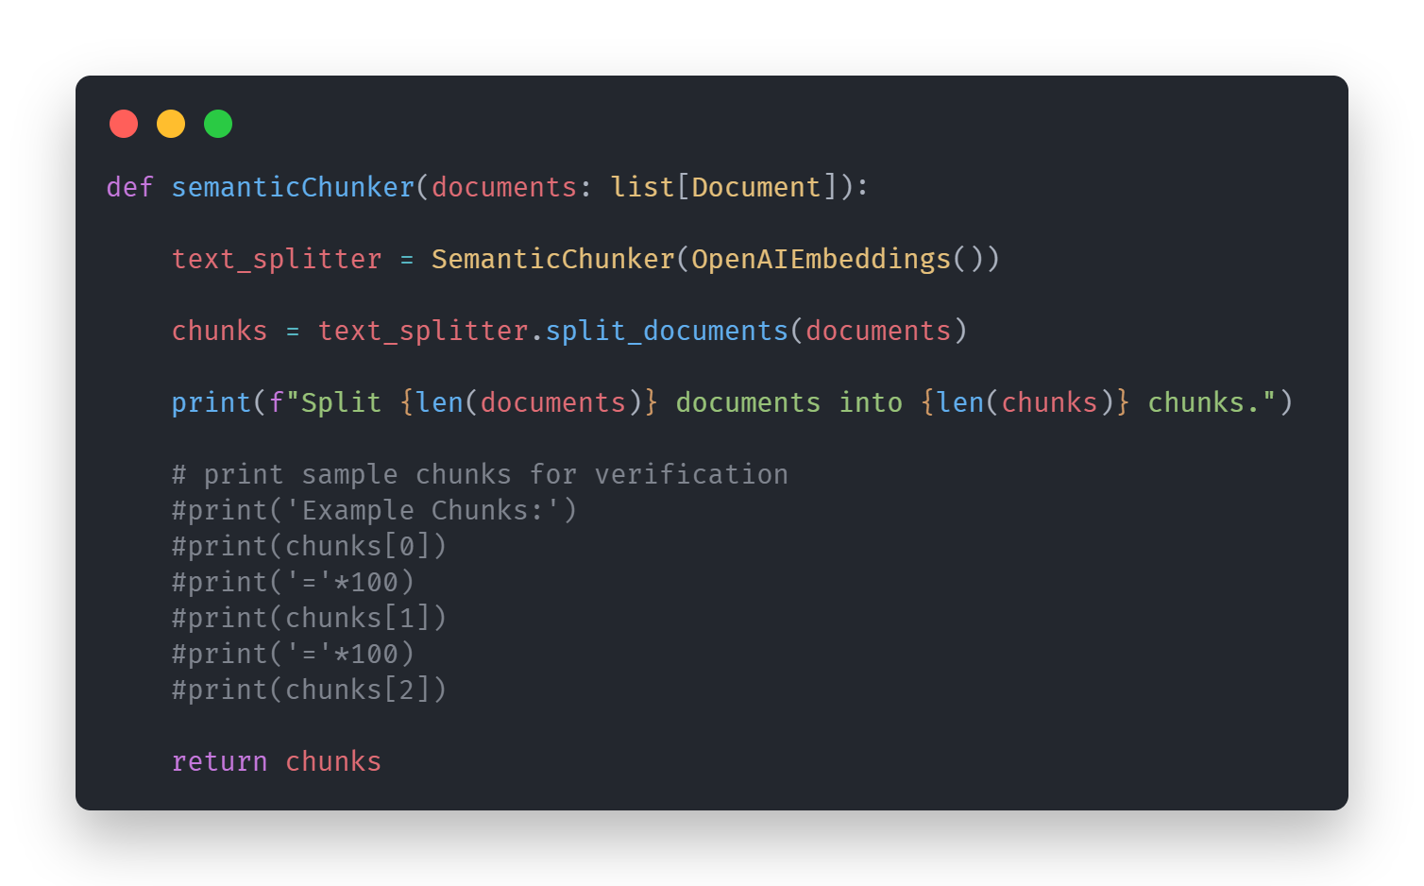
The third part of dataProcessing is the semantic chunking. Chunking is the concept of splitting up the document into smaller segments so that the rag model is more efficient and providing the LLM with precisely the information needed for the specific task, and nothing more.² I chose semantic chunking, which splits chunks into sentences, then groups into groups of 3 sentences, and then merges one that are similar in the embedding space. ³ As a result, each chunk is logical, and self-contained. This approach makes it so that the retrieved context is useful with no cutoff while reducing any redundancies. However, part of it being self-contained means the chunks are smaller and therefore much less therefore even trying to print the first three sample chunks might cause a key error as there might be less than three chunks on smaller documents so proceed with caution while testing.
² Mishra, A. (2024, January 15). Five levels of chunking strategies in Rag: Notes from greg’s video. Medium. https://medium.com/@anuragmishra_27746/five-levels-of-chunking-strategies-in-rag-notes-from-gregs-video-7b735895694d
³ How to split text based on semantic similarity. 🦜️🔗 LangChain. (n.d.). https://python.langchain.com/docs/how_to/semantic-chunker/
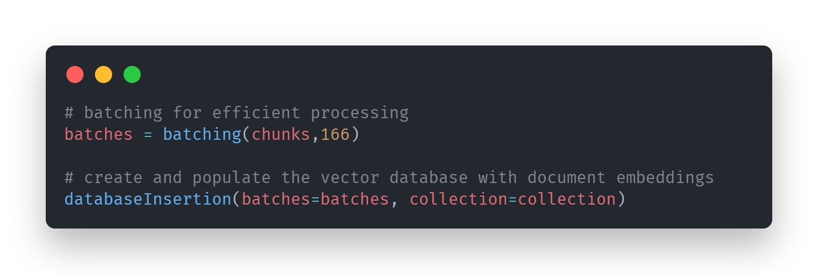
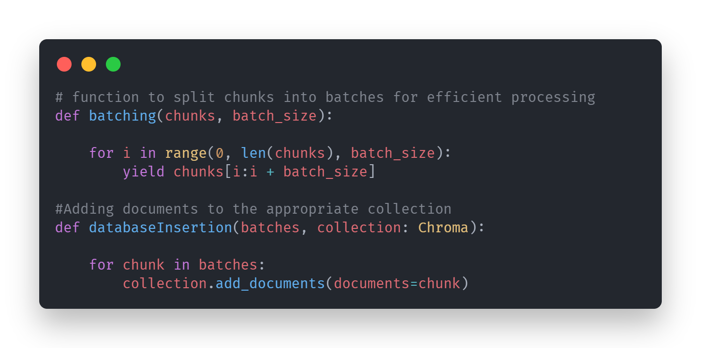
And this is the final parts of dataProcessing, the batching for efficiency and adding the documents into the vector store.
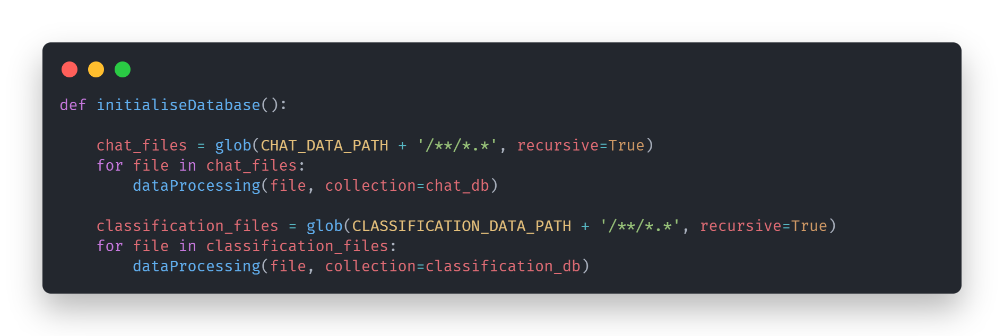
While other functions I chose not to highlight are just other functions I tested and compared against the ones I use and are kept on for posterity’s sake only. This function is used not in this file but app.py to initialize the database. It searches recursively at the file path given and based on the pattern returns a list of file paths before it is being processed by dataProcessing function.

app.py
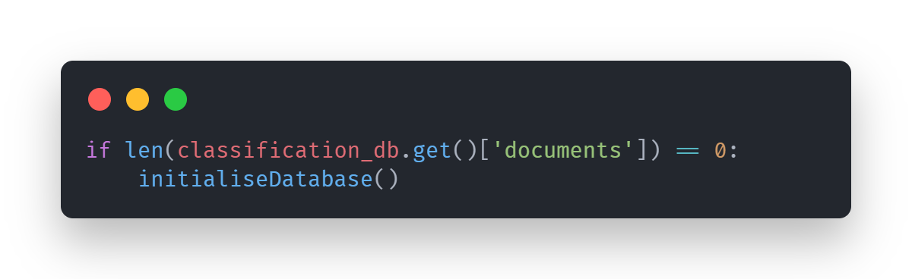
This file initializes a lot of the initial data such as the vector database which in turn initializes the keywords databank and starts up the chat model which initializes the memory persistence or the sqlite3 file. The code above checks if there is any documents in the classification collection of chroma db and if there is none, it initializes the vector store.
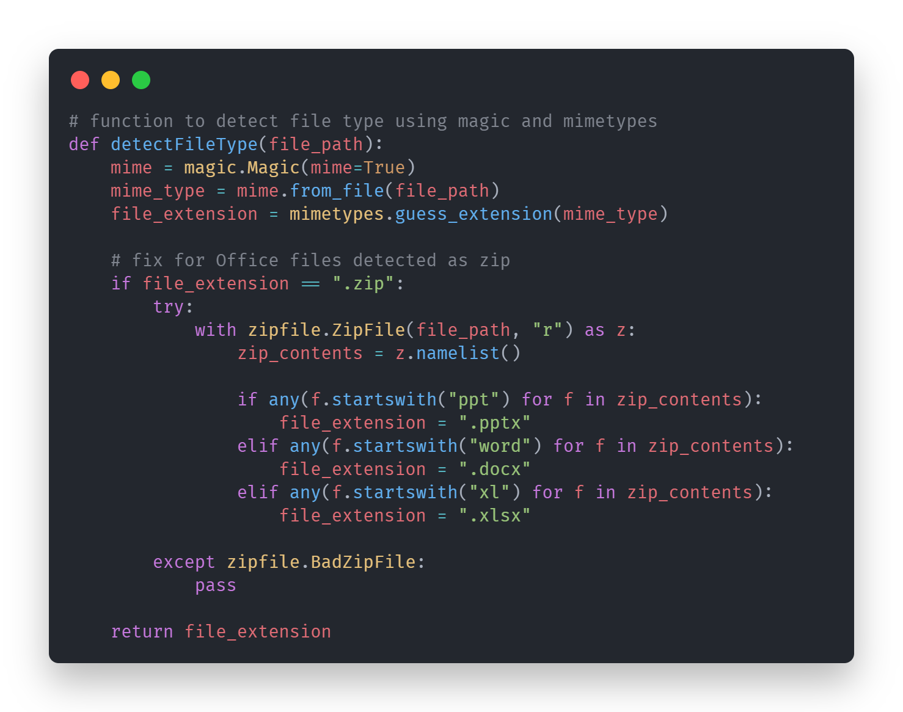
Because the formatting of the powerpoint, documents and excel files are extremely similar to a zip file, when magic interprets the encoding it sees it as a zip, and we need to access the contents to figure out what the actual type of the file is.
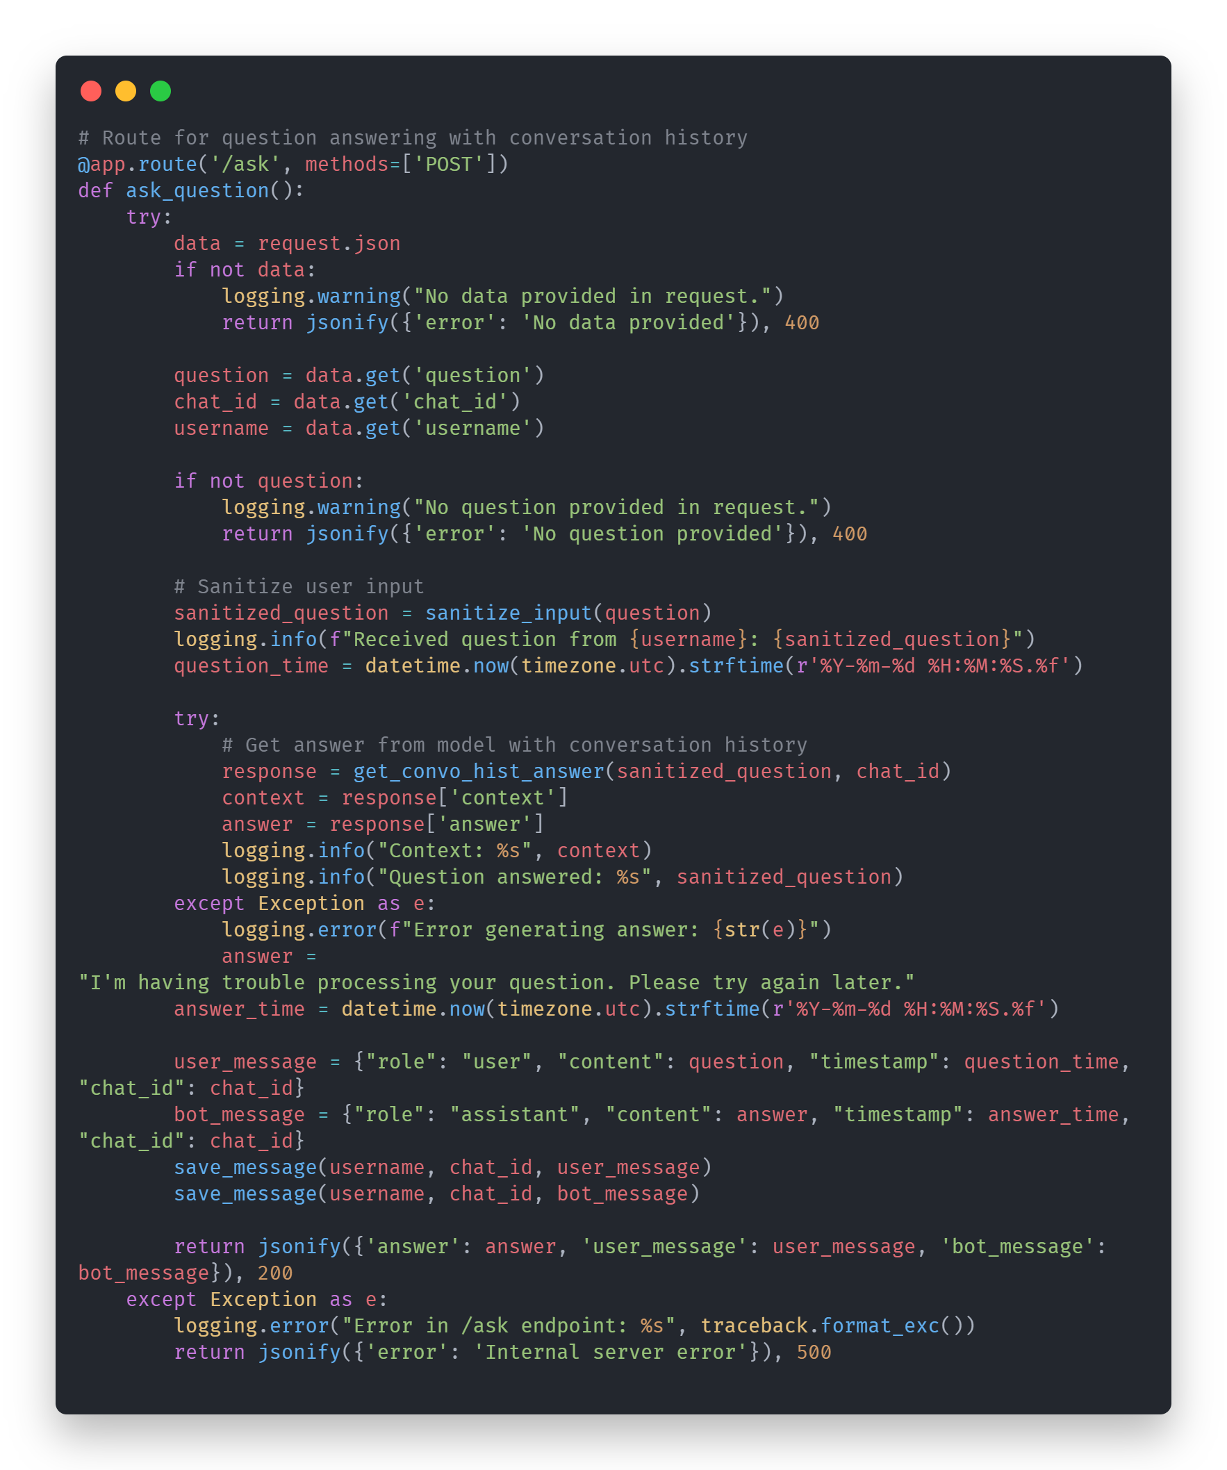
The context is logged because typically when the model can’t return an answer and it’s not that it breaks, basically a llm logic error, it’s typically because the retrieval was not strong enough and either did not pull any chunks or only pulled irrelevant chunks. The timestamps also help in the chat history being displayed to the user in the right order; thus it is separated into question time for when the question was asked and answer time for when the answer was returned.
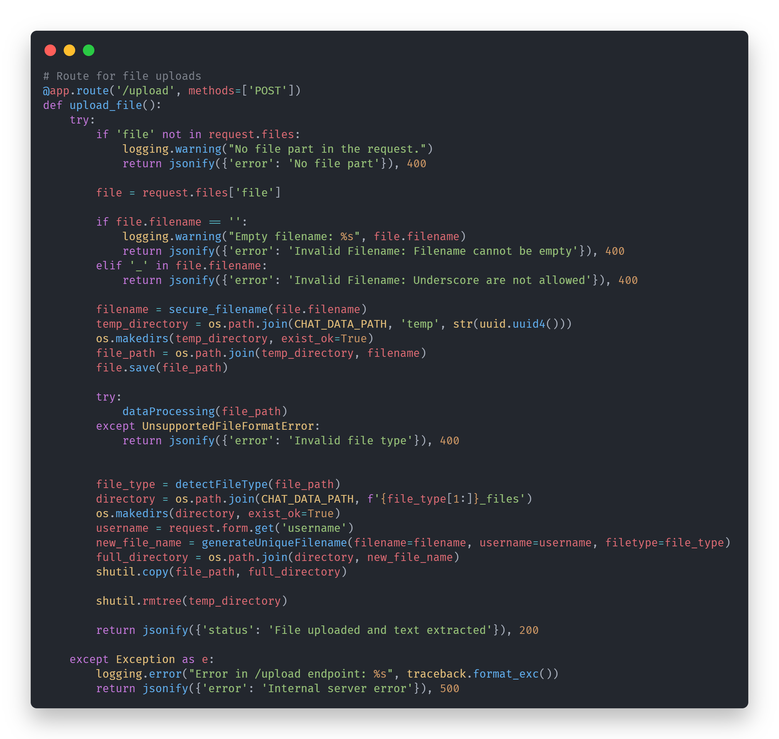
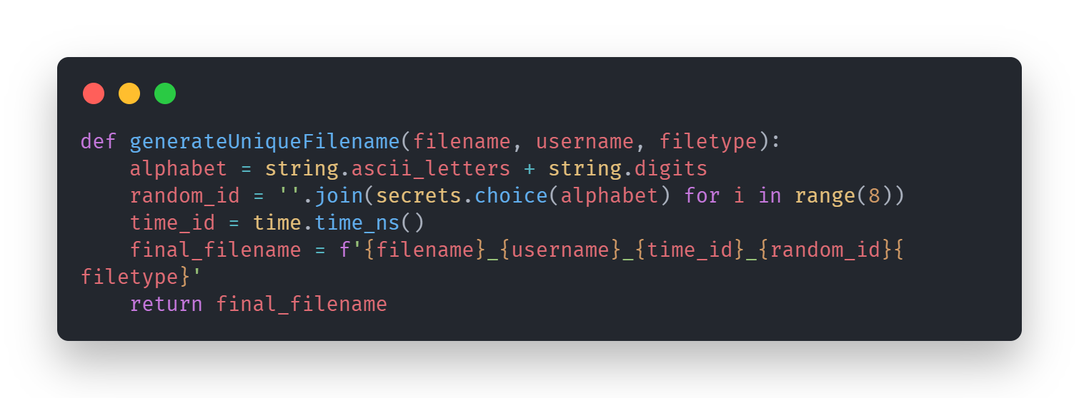
The reason there is a validation to refuse any files with an underscore in it is due to how I renamed the files I renamed them with ‘_’ to separate the various information as shown above and if I were to ever return the file to the user, I would like to strip the additional metadata before returning them and I had a thought to restore the name of the file using string manipulation using the ‘_’ as a marker. There is a lot of redundancies in the code’s validation for safety which feels like double checking. For example, the check to see if it would not return anything has a similar check on the front end as well as the error validation for the file format which is actually using the inbuilt error by unstructured called UnsupportedFileFormatError when in the front end the streamlit’s file uploader object is set to only accept files unstructured can support.
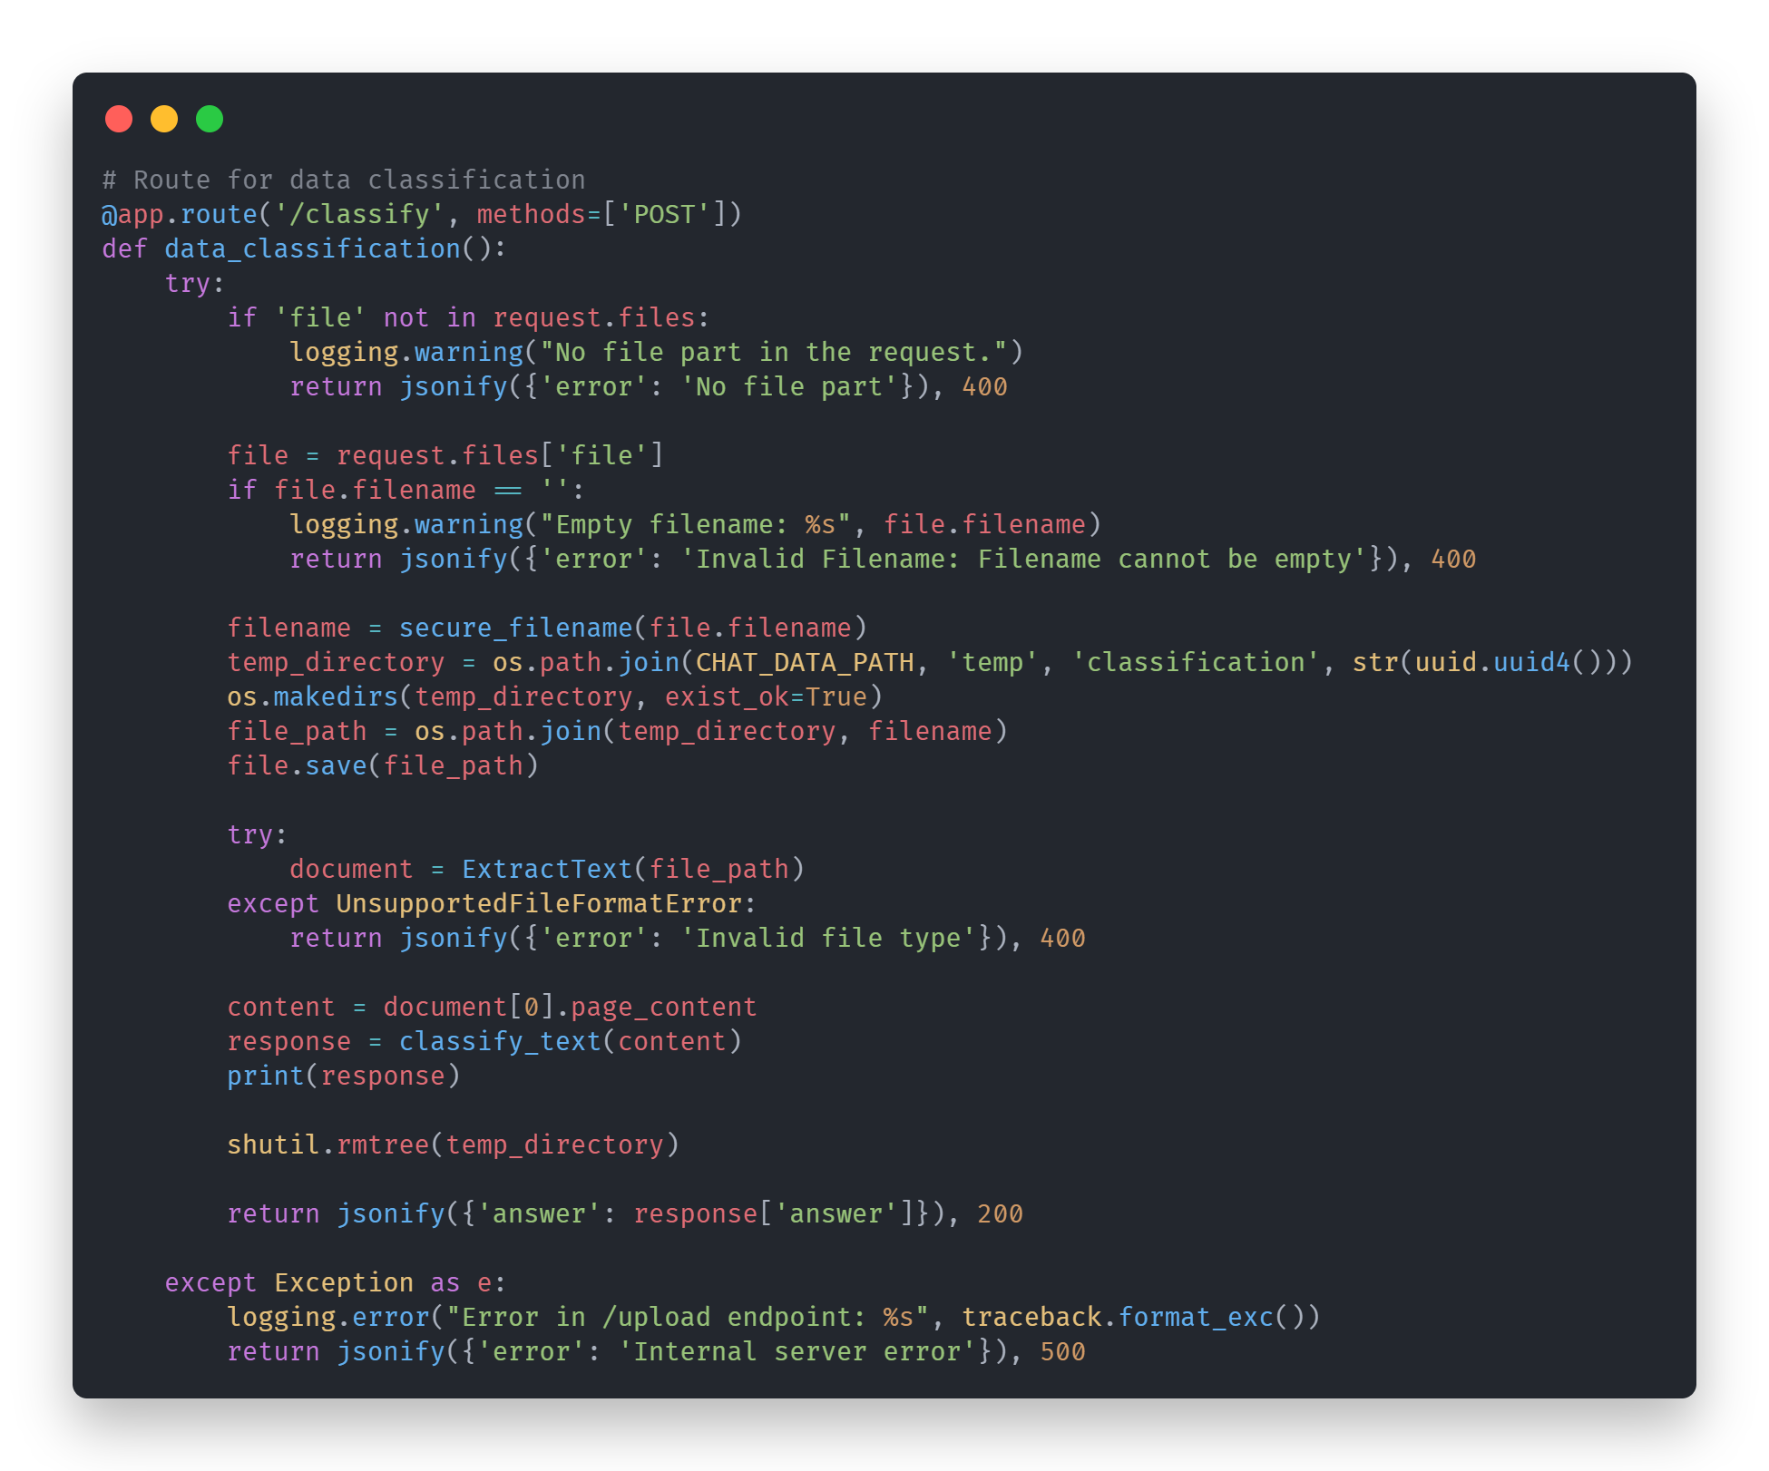
The algorithm is largely the same as file uploads, with how the data is being processed, except the page content is extracted and passed to the model to be processed and the answer returned to the user as well as the contents of the file uploaded is not saved in the system.

chatModel.py
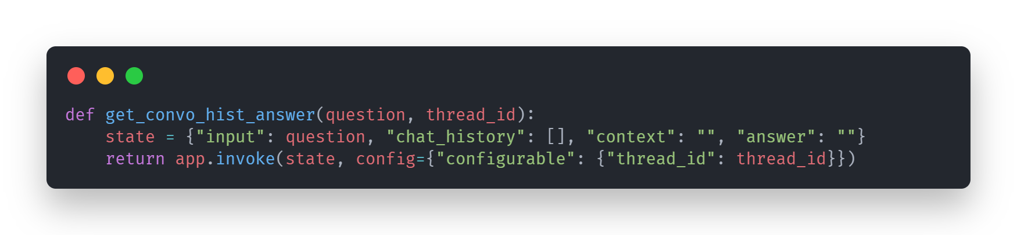
This is the entry point to the model, it sets up the state which tracks various important variables used by the model. Every unique thread id is a new conversation memory for the model.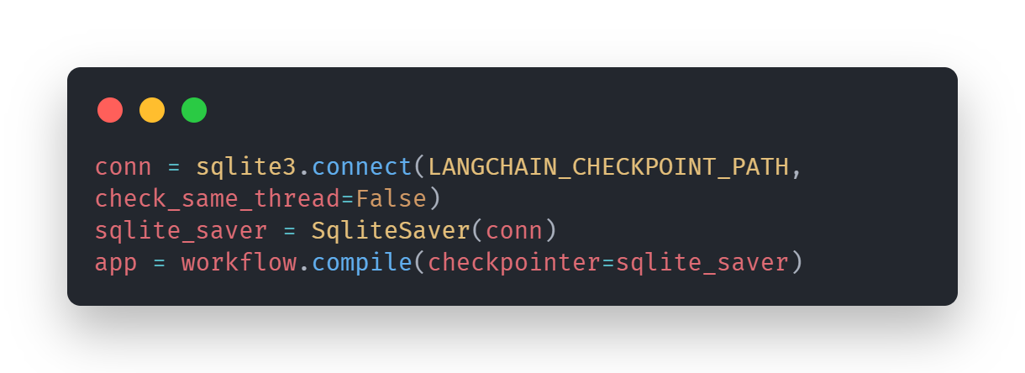
The memory is saved using an sqlite file as well as a function provided by langchain to handle using sqlite to store the memory of the model.
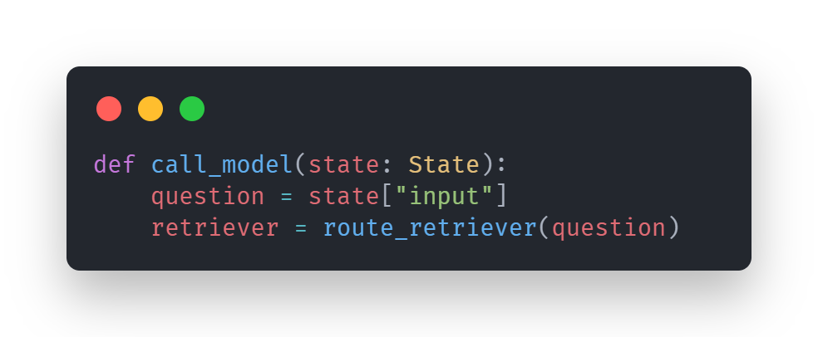
This is the actual model logic, it takes in the state initialized earlier and extracts the question which is passed into the route retriever. The route retriever sets up the keyword filter.
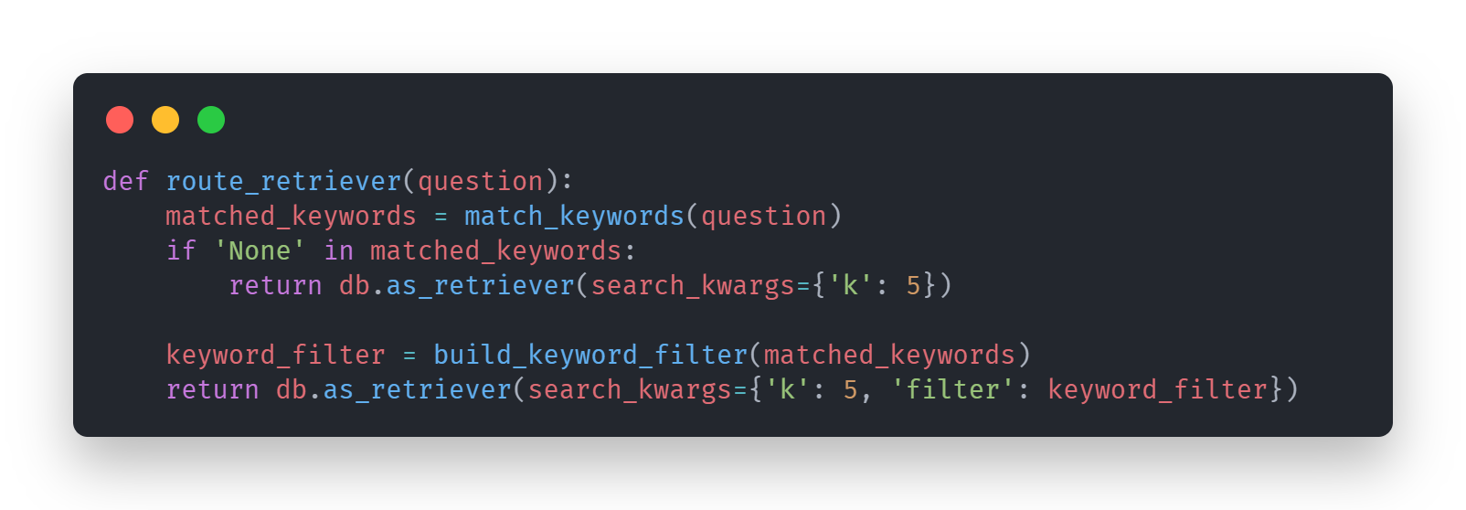
The function processes the question to match the keywords to the existing keyword databank with all the keywords using the match_keywords function, and as a fail safe returns an unfiltered retriever. But if it does match a keyword or keywords it builds a keyword filtered retrieverusing build_keyword_filter function and returns it.
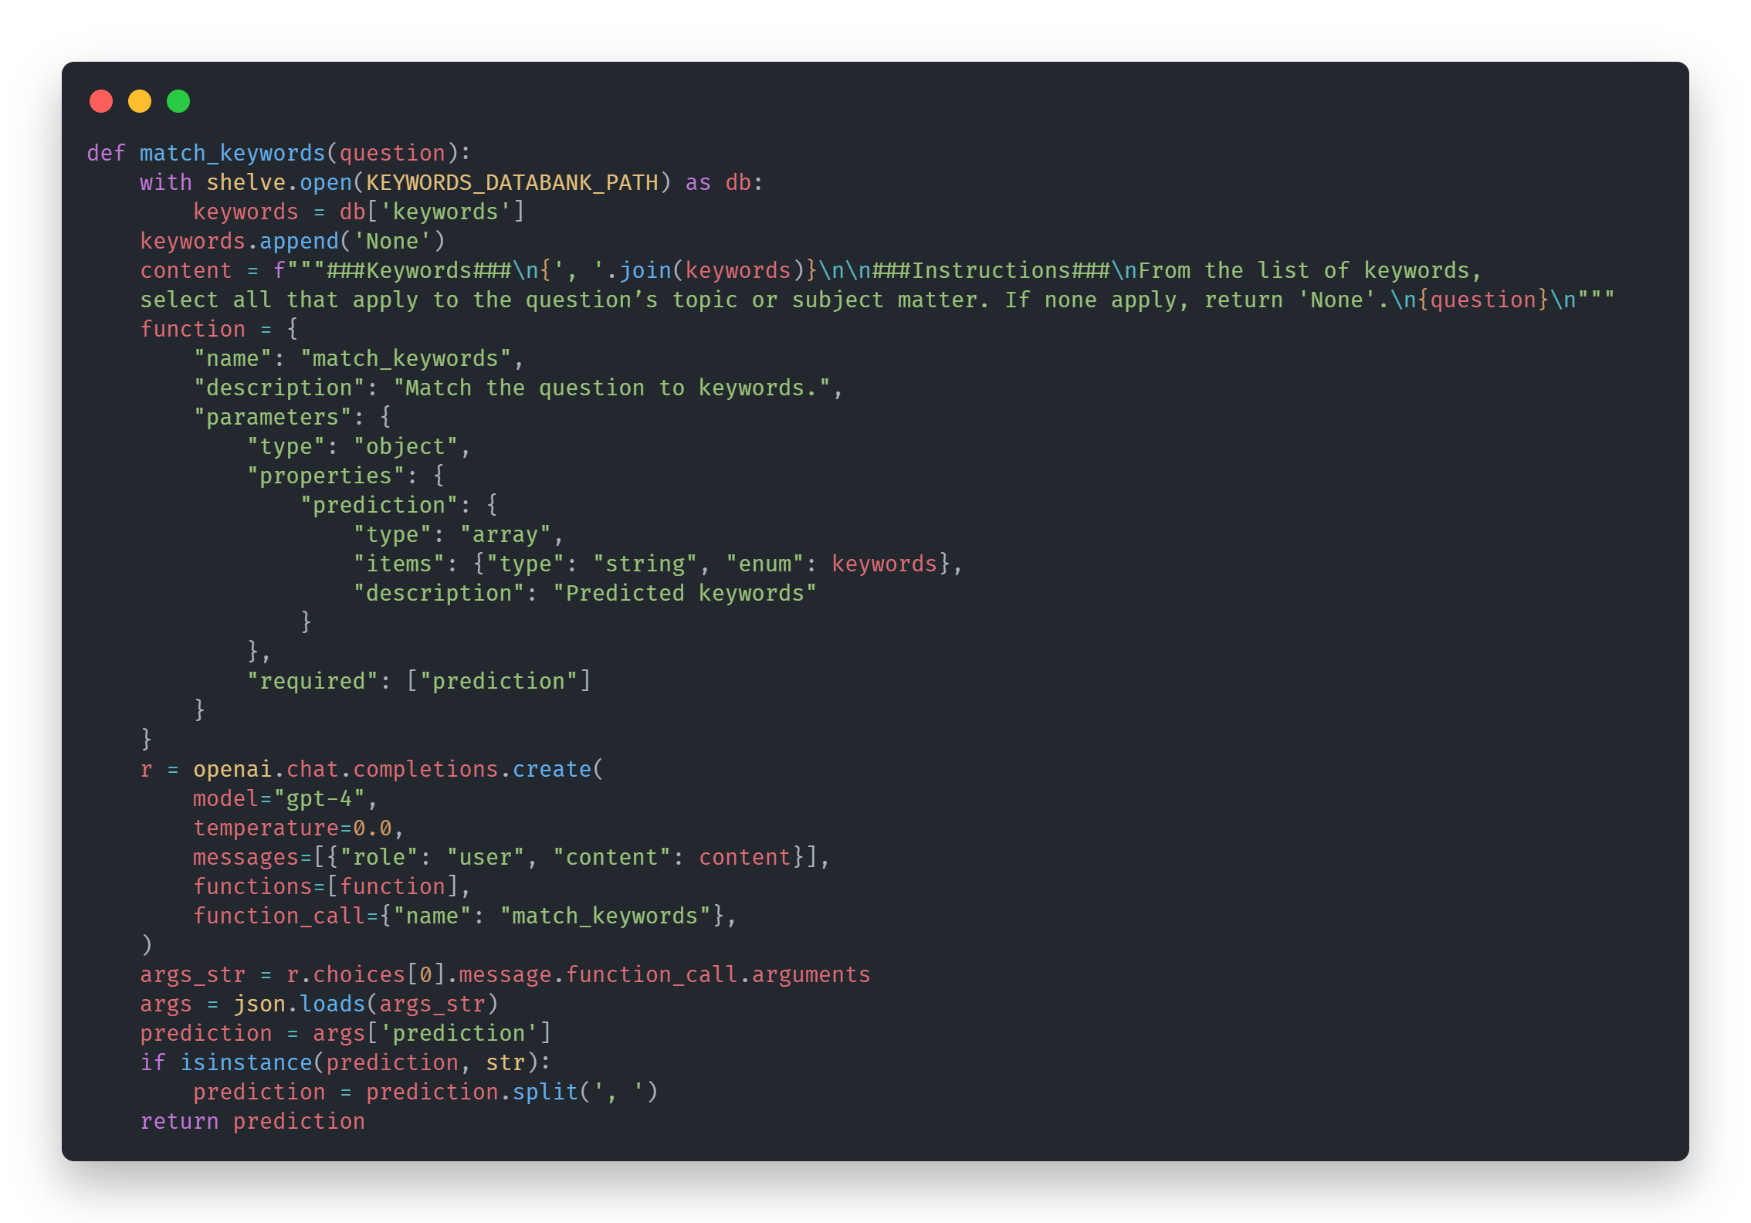
The match_keywords uses Open AI’s chat completion function to do data labelling / text classification on the question to return a list of matched keywords which is then extracted and processed into the appropriate format and returned. This is the best method to do the data labelling / text classification task without any existing training data
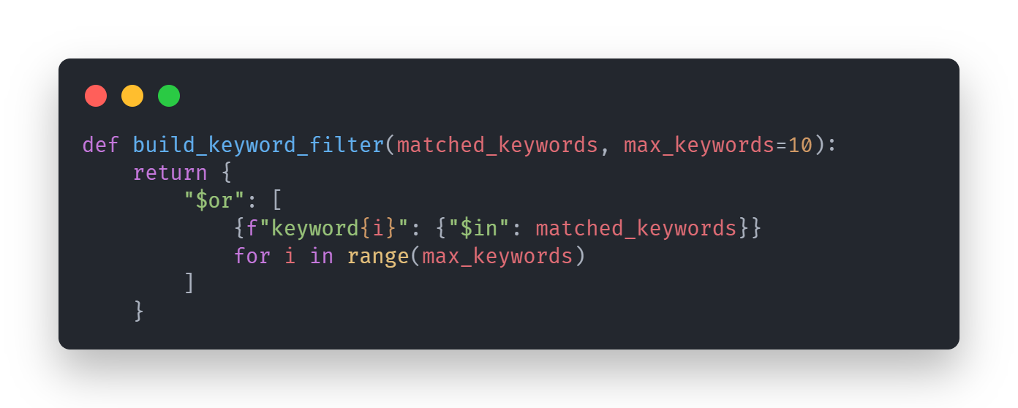
As you remember earlier section talking about the keywords metadata at the data processing stage, it was built specifically so it could be used in this manner, which searches through every individual keyword to match any of the keywords in the list of keywords returned by match_keywords function. It does not matter If the any of keyword’s metadata that is specified here to search in does not exist in the documents, it will simply be ignored.
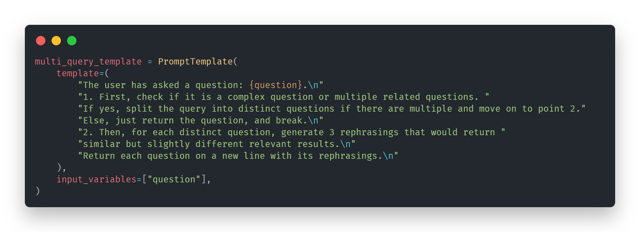
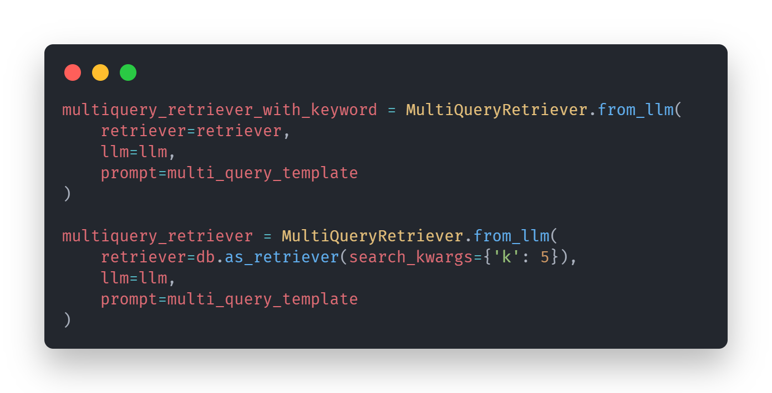
The retrievers are then put inside a multiquery retrievers where the prompt is adapted into three rephrasings used to retrieve the relevant documents, as you may be wondering why there is two, that is to side stop certain limitations of metadata keywords search while still being able to use it for it’s advantages having the best of both worlds. As of currently the keywords filter suffers a great deal of issues such as if there is not an exact match of keywords within the document and even if there is, the right document might not return, 10 keywords is not exactly enough to properly represent the whole documents even with the bigger chunks.
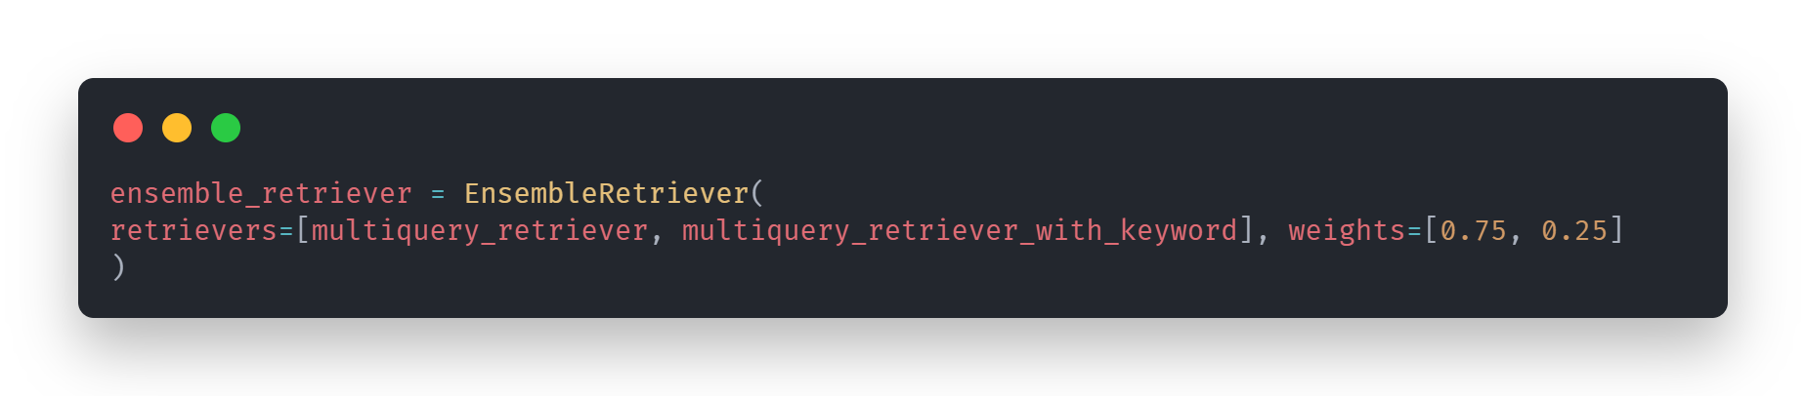

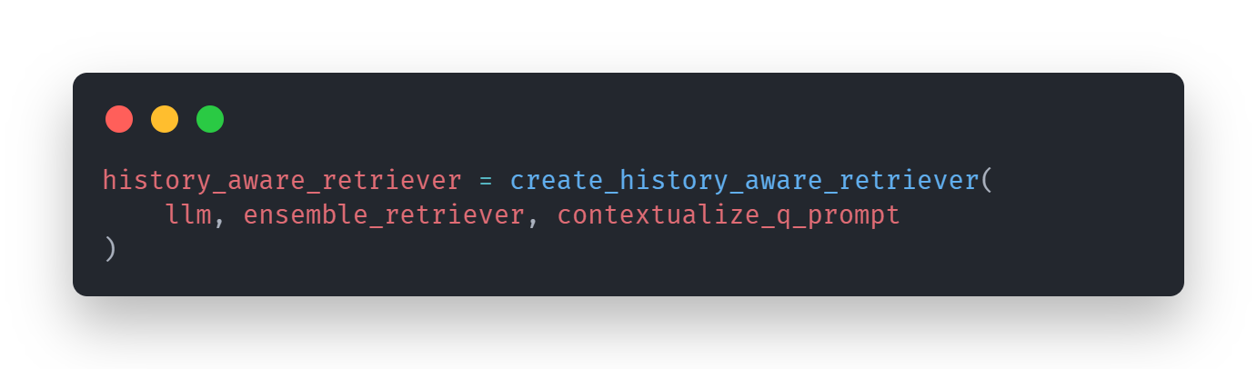
It is then inserted into an ensemble retriever which combines two retriever’s results and reorders the documents retrieved based on the weightage of the retrievers. multiquery_retriever is at 0.75 while multiquery_retreiver_with_keyword is at 0.25.
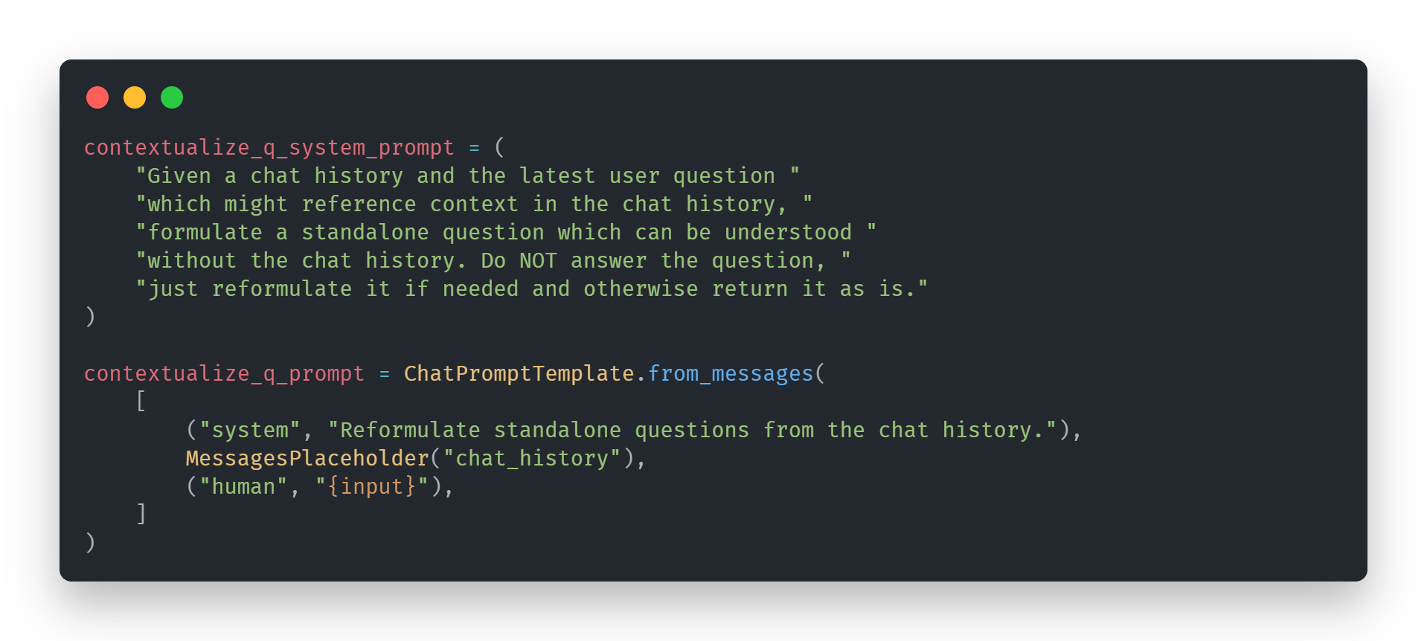
Next, for the chat history, prompt is clear and context rich, where the chat history is passed in, and the prompt clearly states to not answer the question, but to only reformulate a clear standalone question. The prompt also states if the chat history is not needed, then the query should be returned as it is.

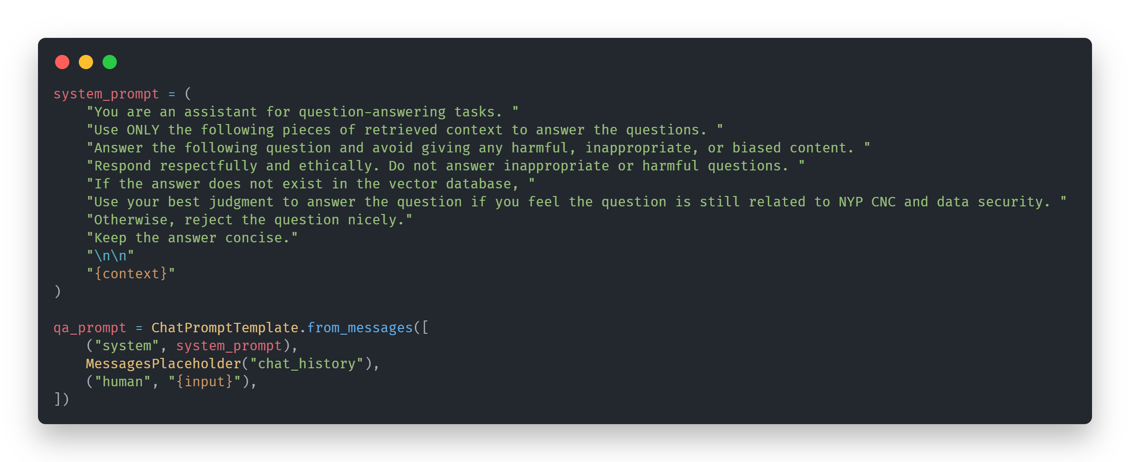
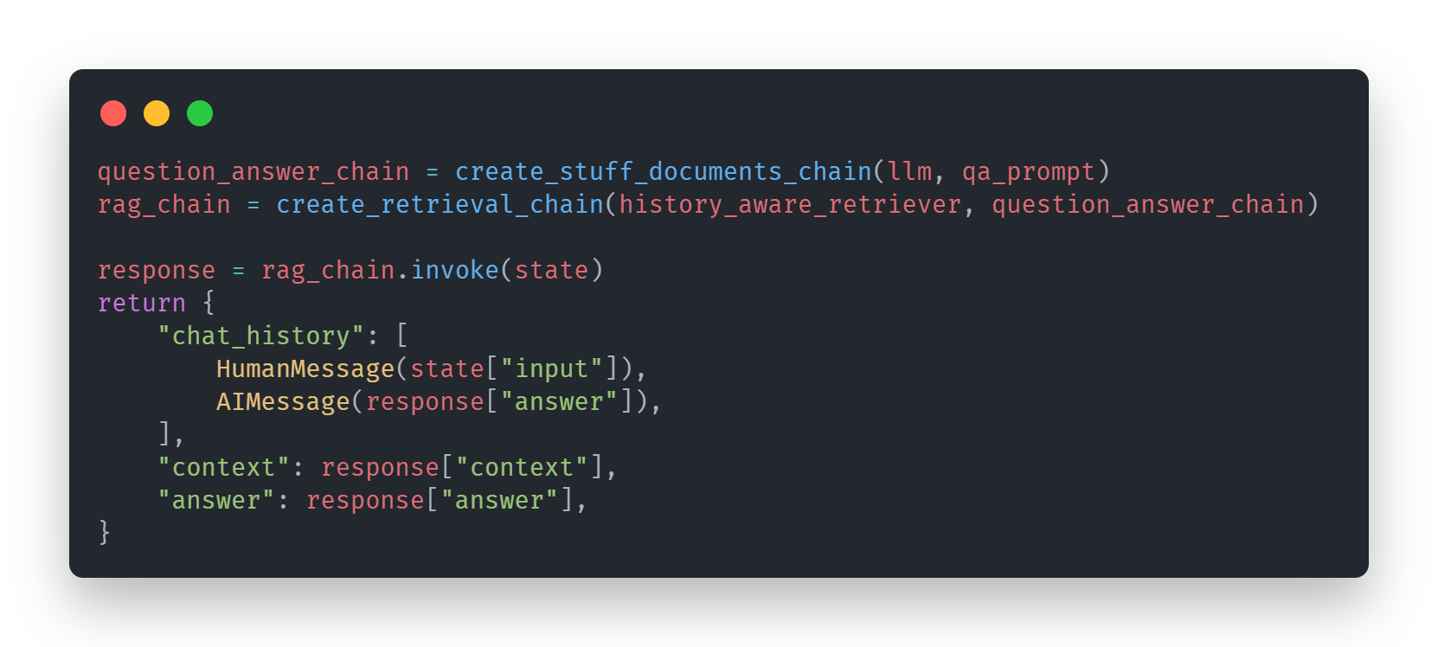Lastly, the answering prompt clearly states the LLM’s role, and the context (RAG) to answer the user query. It is stated that no harmful, inappropriate, or biased response should be returned, and all responses should be respectful and ethical. It is also clearly stated to not answer any queries that are beyond the vector database knowledge, such as to prevent hallucinations (eg. asking for different sensitivity labels could return response cited from other sources, and not the NYP CNC database.)

classificationModel.py

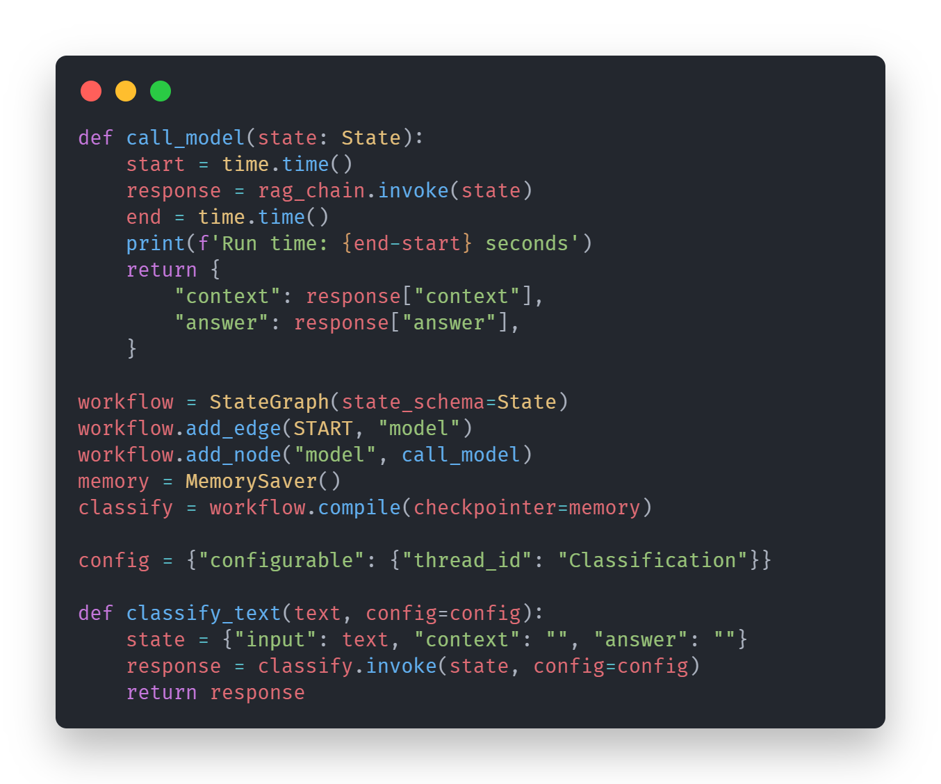
classificationModel.py is similar to chatModel.py a lot simpler just as the file is not saved the conversation memory for the classificationModel is only saved in memory or basically in the ram when the program is running and once it is stopped, the memory is gone, which is appropriate as classification is only supposed to be a one time process and therefore nothing is needed to be saved or persisted.
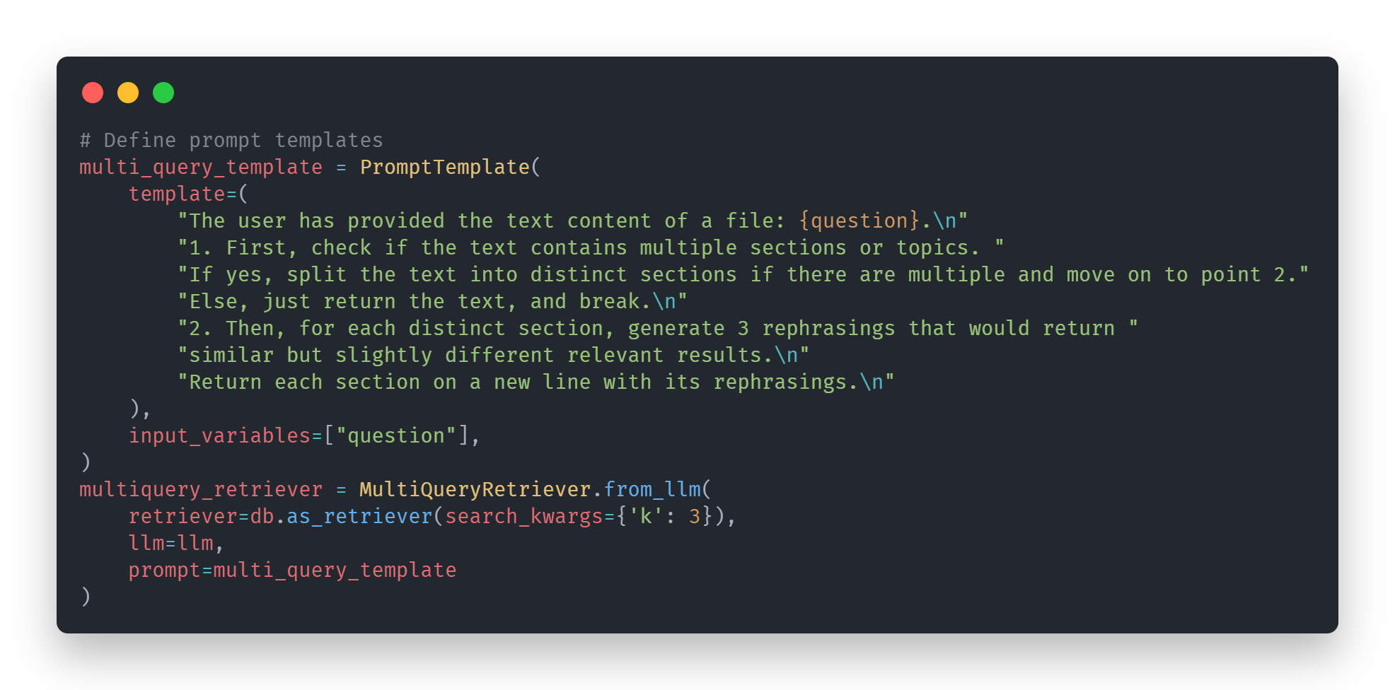
The parts of the model are adaptations of ones from chatModel.py except multiquery retriever now is built for handling breaking down the large document into three separate rephrasings that more completely capture the meaning of the large document.
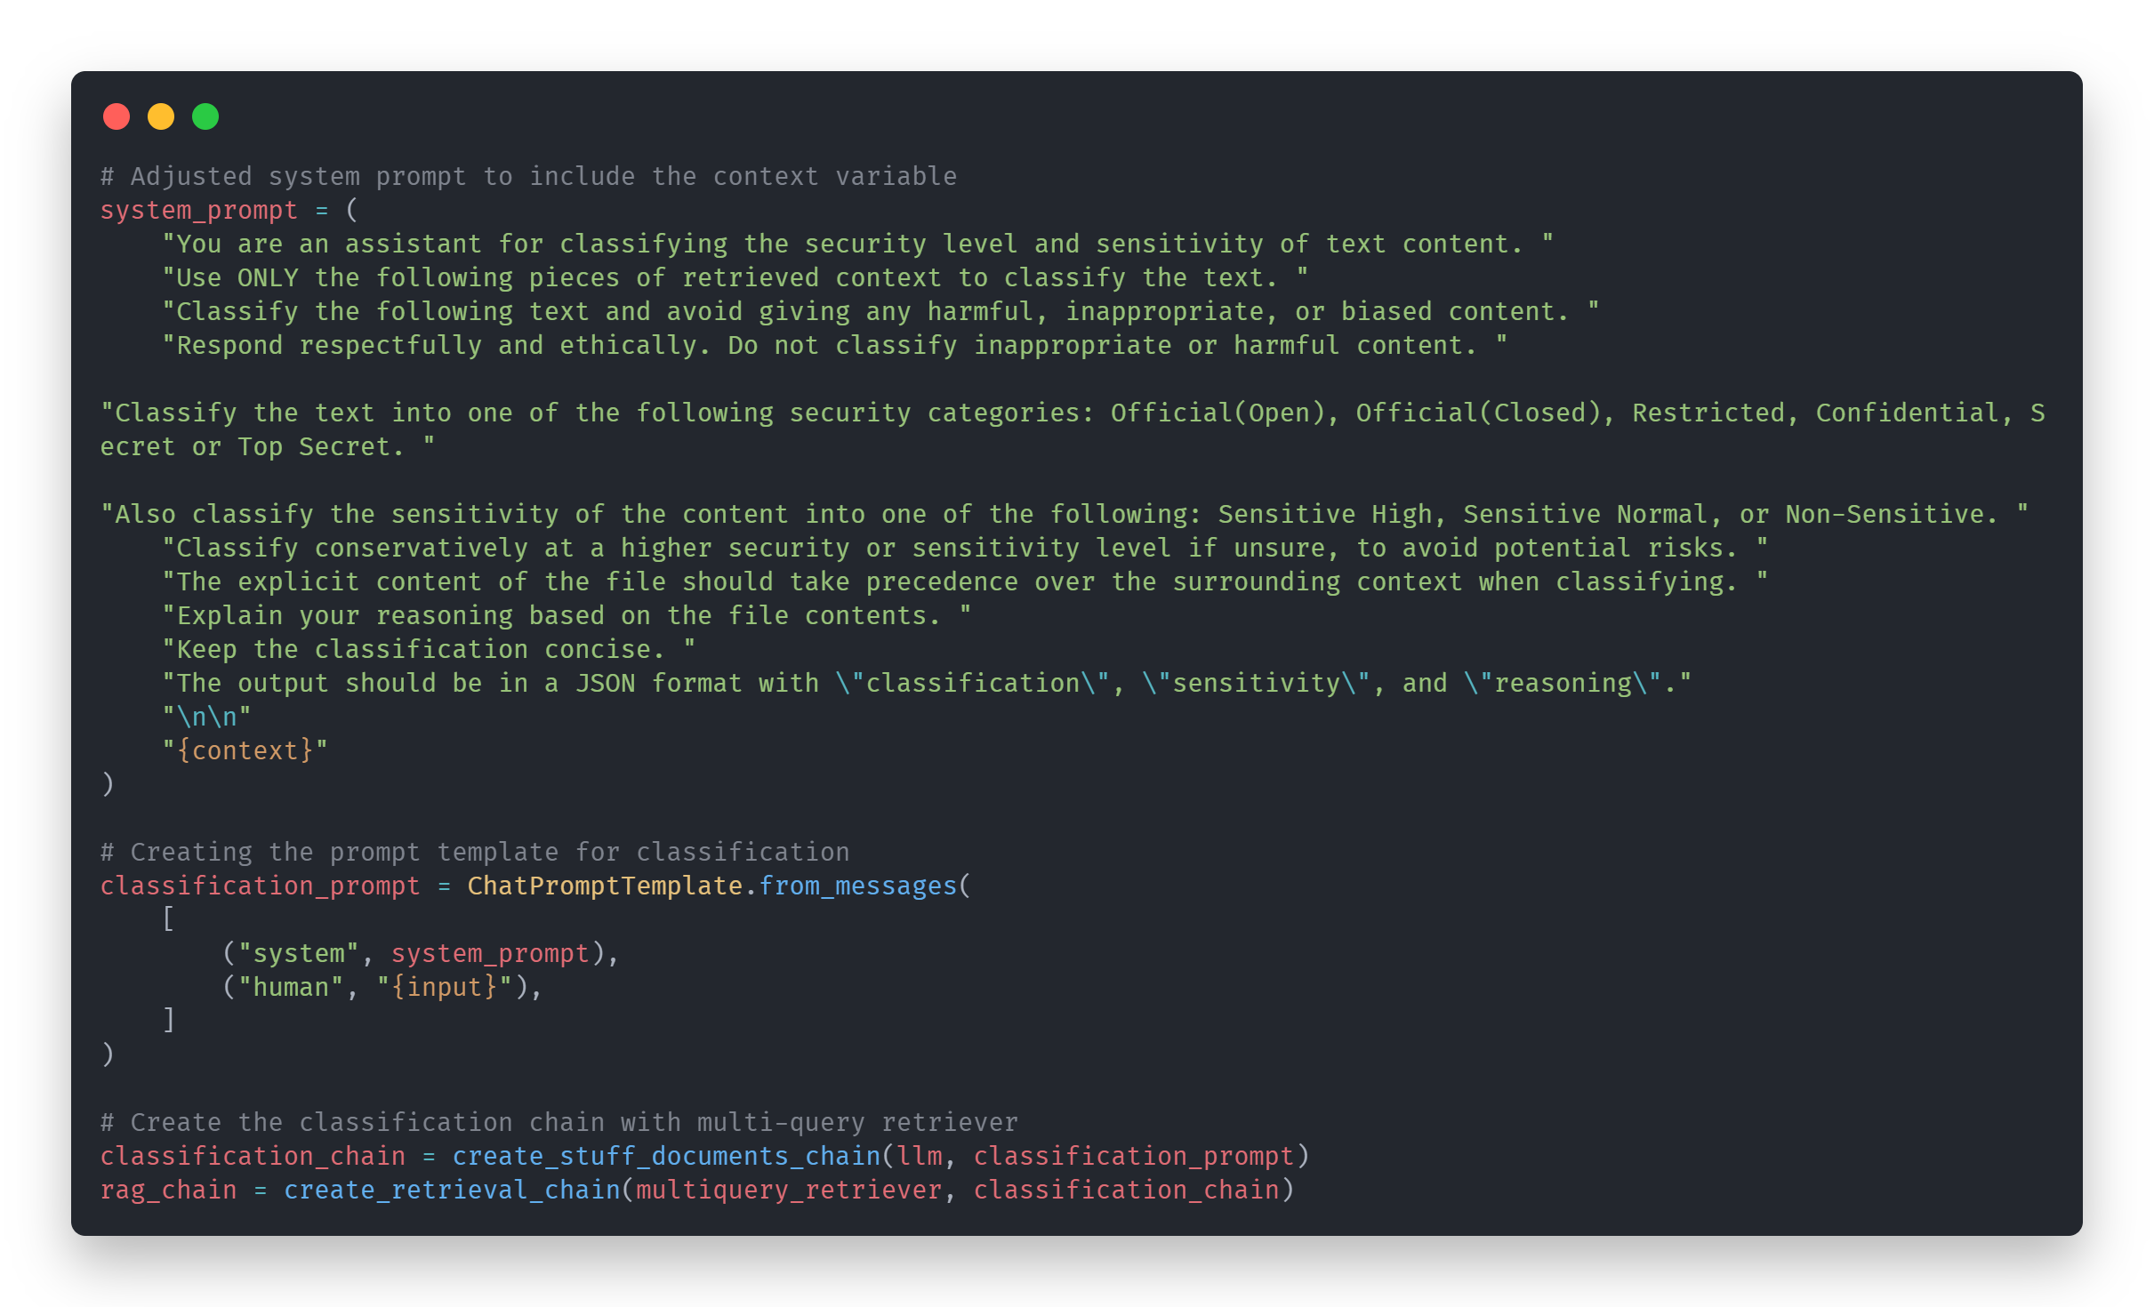
Furtherm0re, instead of simply returning a generated answer, data classification returns, the security category, the sensitivity of the data as well as the reasoning for the above classifications. Then that is returned to the user.

Areas of Improvement
- As discussed extensively, chroma db suffers from a lot of limitations and is extremely limited in features, perhaps exploring a new vector store.
- Returning the data files would be helpful as a reference for the user but to select the correct file out of the pool of files that answered the question
- A way to significantly cut down the latency of the model would be helpful as right now the rag model still takes about a minute to run
- The implementation of async within the data processing would be greatly add to efficiency especially with the implementation of multi file uploads
- As of currently SQLite3 works decently as a memory store but langchain recommends that it be only use for testing and small-scale operations, perhaps a swap to a database such as postgres sql for the memory saver could support it being full production scale
- As mentioned earlier, as of currently the keywords filter suffers a great deal of issues such as if there is not an exact match of keywords within the document and even if there is, the right document might not return, 10 keywords is not exactly enough to properly represent the whole documents even with the bigger chunks.

